A

PROJECT REPORT

ON

**CIVIL ADMINISTRATION SYSTEM**

A THESIS SUBMITTED IN PARTIAL FULFILMENT OF THE ACADEMIC

REQUIREMENT FOR THE AWARD OF DEGREE OF

**MASTER OF COMPUTER APPLICATION**

**COMPUTER SCIENCE AND APPLICATION**

**Submitted**

**By**

**TAPAN KUMAR MAHAPATRA (1705106028)**

**BIRENDRA KUMAR BEHERA (1705106020)**

**PRANGYASINI BEHERA (1705106001)**

**Under the Esteemed guidance of**

**Mr. Manjit Kumar Nayak**

**Assistant Professor**

**Department of CSA**



**DEPARTMENT OF COMPUTER SCIENCE & APPLICATION**

**COLLEGE OF ENGINEERING AND TECHNOLOGY**

**(Techno Campus ,PO-Ghatikia, Mahalaxmi Vihar,Bhubaneswar-751029)**

**2019-2020**

**COLLEGE OF ENGINEERING AND TECHNOLOGY**

**(Techno Campus, PO- Ghatikia, Mahalaxmi Vihar,Bhubaneswar-751029)**

**DEPARTMENT OF COMPUTER SCIENCE & APPLICATION**



**CERTIFICATE**

This is to certify that the Thesis/Dissertation entitled **CIVIL ADMINISTRATION SYSTEM** are being submitted by **TAPAN KUMAR MAHAPATRA,BIRENDRA KUMAR BEHERA,PRANGYASINI BEHERA** with regd.no **1705106028,1705106020, 1705106001** respectively in partial fulfilment of the requirement for the award of the degree of MCA. In to the College of Engineering & Technology is a record of bonafide work carried out by us under our guidance and supervision from September to December 2019.

The results presented in this thesis have been verified and are found to be satisfactory. The results embodied in this thesis have not been submitted to any other University for the award of any other degree.

**INTERNAL GUIDE HOD**

**Mr. Manjit Kumar Nayak Dr. Jibitesh Mishra**

*(***Assistant Professor)****(Associate Professor)**

**COLLEGE OF ENGINEERING & TECHNOLOGY**

**(Techno Campus, PO- Ghatikia, Mahalaxmi Vihar,Bhubaneswar-751029)**

**DEPARTMENT OF COMPUTER SCIENCE & APPLICATION**



**ACKNOWLEDGMENT**

We are extremely grateful to **Professor Dr.Jibitesh Mishra, H.O.D,** Department of CSA, College of Engineering & Technology for their encouragement and valuable guidance in bringing shape to this dissertation.

We are extremely thankful to **Mr. Manjit Kumar Nayak, Assistant Professor,** Internal Guide ,Department of CSA, for their constant guidance, encouragement and moral support throughout the project.

We will be failing in duty if we do not acknowledge with grateful thanks to the author of the references and other literature referred in this Project.

We express our thanks to all staff members and friends for all the help and coordination extended in bringing out this Project successfully in time.

Finally , we are very much thankful to our parents who guided us for every step.

**Date: Tapan kumar Mahapatra**

**(1705106028)**

**Place: Birendra Kumar Behera**

**(1705106020)**

**Prangyasini Behera**

**(1705106001)**

**COLLEGE OF ENGINEERING & TECHNOLOGY**

**(Techno Campus, PO- Ghatikia, Mahalaxmi Vihar,Bhubaneswar-751029)**

**DEPARTMENT OF COMPUTER SCIENCE & APPLICATION**



**DECLARATION**

We **Tapan Kumar Mahapatra, Birendra Kumar Behera, Prangyasini Behera** bearing **Roll No: 1705106028, 1705106020 , 1705106001**respectively a Bonafede student of **College of Engineering and Technology,** would like to declare that the project titled **“CIVIL ADMINISTRATION SYSTEM”** A partial fulfilment of MCA Degree course of College of Engineering & Technology is my original work in the year 2019 under the guidance of **Mr. Manjit Kumar Nayak,** Assistant Professor, Computer Science &Application Department and it has not previously formed the basis for any degree or diploma or other any similar title submitted to any university.

**Date: Student Name**

**ABSTRACT**

Normally the higher authority will reach the public a few times. If they go to meet the authorities, they will be asked to wait for hours. No one will be having the patience to listen to the problem. So, this project is built to connect the local public with the higher officials in the civil Administration Office. The user must register to an account and state a complaint to the authority with the generated unique ID. To validate the identification of the user a OTP is send to the corresponding user email id which is registered by the user during the time of registration. The Admin assign the complaint to the authority. The status of the complaint is updated only by the respective authority. The user has to wait till the authority changes the status of the complaint. Complaint can be easily registered by the user and can be tracked with a unique complaint ID. The user can view the progress of the complaint. This system will not only save the time of the complaint fillers but also lead to track their complaint and its status in a regular interval of time. Once the complaint is solved, the notification is sent to the user email ID.

**INDEX**

**Chapter 1: Introduction------------------------------------------------------------------------8**

* 1. Introduction**-----------------------------------------------------------------------9**
  2. Project Scope**----------------------------------------------------------------------9**
  3. Existing System**-------------------------------------------------------------------10**
  4. Proposed System**-----------------------------------------------------------------10**

**Chapter 2: Literature Survey/Review of Literature-------------------------------------11**

2.1 Introduction--------------------------------------------------------------------------12

2.2 Related Work------------------------------------------------------------------------12

**Chapter 3: System Requirement-------------------------------------------------------------14**

3.1. Software Requirement**------------------------------------------------------------15**

3.2. Hardware Requirement-----------------------------------------------------------15

**Chapter 4: Software Requirement Analysis----------------------------------------------16**

4.1. System planning and the initial Investigation-------------------------------17

4.2. Information Gathering------------------------------------------------------------17

4.3. Feasibility Study--------------------------------------------------------------------18

4.3.1. Technical Feasibility-----------------------------------------------------18

4.3.2.Economic Feasibility-----------------------------------------------------19

4.3.3. Cost Benefit Analysis---------------------------------------------------19

4.3.4. Legal Feasibility----------------------------------------------------------20

**Chapter 5: Project Plan & Approach--------------------------------------------------------21**

**Chapter 6: Project Schedule------------------------------------------------------------------23**

**Chapter 7: Data Flow Diagram-----------------------------------------------------------------25**

7.1 Introduction-----------------------------------------------------------------------------------26

**Chapter 8: Software Design--------------------------------------------------------------------32**

8.1. Scope-----------------------------------------------------------------------------------33

8.2. System model specification-------------------------------------------------------33

8.3. Class Diagram-------------------------------------------------------------------------35

8.4. Use Case Diagram-------------------------------------------------------------------36

8.5. ER Diagram----------------------------------------------------------------------------43

8.6. System Architecture----------------------------------------------------------------44

**Chapter 9: Coding /Code Templates---------------------------------------------------------45**

**Chapter 10: Testing-------------------------------------------------------------------------------52**

**Chapter 11: Database Design View----------------------------------------------------------60**

**Chapter 12: Output Screens--------------------------------------------------------------------64**

**Chapter 13: Conclusion-------------------------------------------------------------------------72**

**Chapter 14: References/Bibliography-------------------------------------------------------75**

**Chapter 1.INTRODUCTION**

**1.1 INRODUCTION**

This project is built to connect the local public with the higher officials in the civil Administration system. The user must register an account and launch a complaint to the authority with the generated unique ID. The system allows user to register and as soon as they register an account with unique id is created in the system. The user can then register complain by upload Image with description. The user will receive a unique complaint id from which he can keep track of that complaint. The admin can access the system to add new authority, edit or delete them. Admin can view all the complaints but he cannot edit or update the status of the complaint. Admin can only view the progress in complains. Authority will have their separate login where they can view all the complaints, update the status of the complaints. After the complaints is solved the authority send a notification to the user registered email id that the complaint is solved.

**1.2. Project Scope**

* The system connects local people with higher authority.
* User can post the problem he is facing and can upload the images and videos of the problem.
* User can suggest new ideas to solve the problem.
* The system can save the times of complaint filters.
* The system also helps the user to track the complaint and its status.
* This system helps the authority to avoid paperwork.
* This system helps the authority to avoid the lengthy work.

**1.3. EXISTING SYSTEM**

In the existing system the citizens must go to the government office for any kind of help. For complaining about a problem the citizens go the government office but cannot get the details of the problems and some other services. This system doesn’t have much popularity and is not user friendly.

The following are the drawbacks present in the existing system:

1. No registration facility is provided and can post the problem directly.
2. Have to install suitable fonts and software available in the website for using the system.
3. Can’t get information regarding funds allotted to the problem and other basic information.
4. Fake problem can be entered and there is no possibility to verify before solving the problem.
5. A citizen can’t give a suggestion for solving the problem in a better way.

**1.4. Proposed solution**

In the proposed system the citizen need not go to the government office for getting his problem solved. He can get his problem solved by posting his problem in this proposed system and he can suggest a possible solution to the problem posting on the system. He can even get the information of the funds and other details of his place in detail through this system. Our proposed system provides solution to existing system by extending its facilities as follows:

1. Registration is provided so that officer can solve the problem easily.
2. Complete information regarding the place is display.
3. Can suggest a solution for solving the problem in a better way.
4. Can comment on the government’s decision.

**Chapter 2: Literature Survey/Review of Literature**

**2.1. Introduction**

A literature review is a search and evaluation of the available literature in your given subject or chosen topic area.A lot of projects and researches has been done aiming in proper solving the problem of users.

**2.2. Related Work**

Here are some related work of the civil administration system

**2.2.1. Android Civil Administration Reporting**

***Internal Journal of Advance Research, Ideas And Innovation In Technology***

***(ISSN:2454-132X,Impact Factor:4.295)***

In this project user must register an account and launch a complaint to the authority with the generated unique ID. The system allow the user to register and as soon as they register an account with unique id is created in the system. The user must require an Android application to register a complaint by mobile or desktop. The status of the complaint is updated only by respective authority. The user has to wait till the authority changes the status of the complaint. Complaints can be easily registered by the user and can be tracked with the unique complaint ID. The user can then view the progress of the complaint. This system will not only save the time of the complaint fillers but also lead to track their complaint and its status in a regular interval of time. Once the reply of the complaint is given, the user will get the update on his smartphone and email address as well.

**2.2.1. Android Civil Administration Reporting**

***International Journal for Research in Applied Science & Engineering Technology(IJRASET)***

***(*ISSN:2321-9653;IC Value: 45.98; Impact Factor: 6.887)**

In India people don’t have any direct communication between the government and public in an efficient way for solving the problems i.e. for getting a problem solved in our place we have to bribe the officials and get them solved in 2 months which can be solved actually in 1 month of time. In order to overcome this problem previously National Informatics Centre has launched a site named Prajavani through which public can post the petitions or complaints in the site and get them solved in a specified time and can also know the status of the complaint or petition he has lodged at any time.

NIC has launched this site with the goal of Right TO Information Act (RTI Act) i.e. providing the complete information of a place to the user at any time. But it failed in providing the complete information to the public and is providing only the complaint lodging facility to the public. In order to make the goal of NIC come true we are going to develop a system which will be able to provide the complete information to the public at any point of time regarding the problems they are facing currently and what is the impact of it and then how effectively the funds are utilized for the development purpose can be known by public which also includes the online discussion forums and feedback forms which will help them to communicate well with the government. It concludes by publishing a newsletter and a magazine to the registered users of the system which gives the complete details of the district for every month.

**Chapter 3.System Requirement**

**3.1. Software Requirement**

**3.1.1 .** Frontend

3.1.1.1. Android Development Tools

3.1.1.2. Advance Java

3.1.1.3. XML

3.1.2.Backend

3.1.2.1.MySQL

3.1.3.IDE

3.1.3.1.Android Studio

3.2.**Hardware Requirement**

3.2.1.**Application Requirement**

3.2.1.1. Android version 6.0 (Marshmallow onwards)

3.2.1.2. 4GB RAM

3.2.1.3. 1.2 GHZ Processor

3.2.2. Development Environment Requirement

3.2.2.1. Intel i3 5th Generation Processor

3.2.2.2.Windows 10 / UBUNTU 14.0.4

3.2.2.3. Android Studio Installed

**Chapter 4:Software Requirement Analysis**

**4.Software Requirement Analysis**

Analysis is a detailed study of the various operations performed by a system and their relation within and outside the system. A key question is what must be done to solve the problem. One aspect of the analysis defining the boundaries of the system and determining whether or not a candidate system should consider other related system. During analysis data are collected on the available files decision points and transaction handled by the parent system. Some logical system models and tools are used in the analysis. Data flow diagrams, interviews, onsite observation and questionnaires are examples, the interview is commonly used in analysis. It requires special skill and sensitivity to the subject being interview bias in data collection and interpretation can be problem.

Training experience and common sense are required for collections of the information are needed to do analysis. Once analysis is completed, the analyst has firm understanding of what is to be done. The next step is to decide how the problem might be solved. Thus in system design, we be move from the logical to the physical of the life cycle.

**4.1. System Planning and the initial investigation**

The most critical phase of managing system projects is planning to launch a system investigation, we need plan detailing the steps to be taken, the people to be questioned and they out come expected. The initial investigation has the objective of determining whether the users request has potential merit. The major steps are defining user requirements. When the initial investigation is completed. The user receives a proposal summarizing the finding the recommendation of the analyst.

**4.2. Information Gathering**

A key part of feasibility analysis is gathering information about the present system. The analyst knows what information to gather, where to find it, how to collect it and what to make of it. The proper use of tools for gathering information is the key to successful analysis. The tools are the traditional interview, questionnaire , and on-site observation. We need to Know, for example how to structure an interview, what makes up a questionnaire, and what to look for on-site observations. These tools when learned help analysis assess the effectiveness of the present system and provide the groundwork for recommending a billing system.

**4.3. Feasibility Study**

The main objective of the preliminary analysis is to identify the problem, evaluate the system concept of feasibility , and perform the economic and technical analyses perform the cost benefit analysis. After the clarification analysis the solution proposed it is checked that it is practical to implement that solutions. This is done through the feasibility study. It is checked for various aspect whether the proposed solution is technically or economically feasible or not. On the basis if which it has been categorized into four classes viz

1. Technical
2. Economic
3. Legal
4. Operational

The outcome of the preliminary analysis should be clear so that an alternate way to do the job can be found out.

**4.3.1. Technical Feasibility**

During the technical feasibility studies following issues are taken into consideration

1.Whether the required technology is available or not?

2. Required resources are available or not?(Manpower, programmer, software and hardware etc)

Once the technical feasibility is established, it is important to consider the monetary factors also. Since it might happen that developing a particular system may be technically possible but it may be require huge investments and benefits may be less. For evaluating this, economic feasibility of the proposed system is carried out.

As in our proposed system our team has technically trained manpower with knowledge of developing the system. We are going to use web technology in our system, which is readily available. Software to be used is also available easily. So technically the project is feasible.

**4.3.2. Economic Feasibility**

For any system if the expected benefits equal or exceed the expected costs, the system can be judged to be economically feasible. In economic feasibility, cost benefit analysis is done in which expected costs and benefits are evaluated.

Economic analysis is used for evaluating the effectiveness of the proposed system. In economic feasibility, the most important is cost benefit analysis. As the name suggests, it is an analysis of the cost to be incurred in the system and benefits derivable out of the system.

As in our institute the hardware and software required for this type of system is already available so economically our project is feasible.

**4.3.3. Cost Benefit Analysis**

Developing an IT application is an investment. Since after developing that application it provides the organization with profits. Profits can be monetary or in the form of the improved working environment. However, it carries risks, because in some cases an estimate can be wrong. And the project might not actually turn out to be beneficial.

Cost Benefit Analysis helps to give management a picture of cost, benefits and risks. It usually involves comparing alternate investments.

Cost Benefit determines the benefits and saving that are expected form the system and compare them with the expected costs.

The cost of an information system involves the development cost and maintenance cost. The development costs are one time investments whereas the maintenance cost are recurring. The development cost is basically the cost incurred during the various stages of the system development.

Each phase of the life cycle has a cost. Some examples are:

1. Personal
2. Equipment
3. Supplies
4. Overheads etc.

In proposed system all hardware and Software are available in the company so cost is 0%.

**4.3.4. Legal Feasibility**

It includes study concerning contracts, liability, violation and legal other traps frequently unknown to the technical staff.

**Chapter 5: Project Plan & Approach**

**5. Project Plan & Approach**

Software development team consists of 3 members.

***Phase-1: Requirement Gathering and Analysis***

Gathering system requirement and prepare a System Requirement Specification document.

After collect the information it is analysed that the available resources can fulfil all the requirements. And it is also be examined that what resource will be used.

***Phase-2: System Design***

Make a detailed analysis of the system and prepare a System Design Document on the basis of SRS.

***Phase-3: Prepare UTC/STC for testing the software***

Prepare Unit Test Cases document. This document will be used to verify whether the functional requirements of the system have been met.

***Phase-4: Develop the software***

Develop the planned system

***Phase-5: Test the software using the prepared UTC/STC and Rework if needed***

Run your software programs using the respective UTC to verify & test the software.

***Phase-6: Demonstrate the software to users & Implement it***

**Chapter 6: Project Schedule**

**PROJECT SCHEDULE**

|  |  |  |
| --- | --- | --- |
| ***Step #*** | ***Time Frame*** | |
| **Phase 1**. **Requirement Gathering** | **18 Days** | |
| **Phase 2. System Design** | **25 Days** | |
| **Phase 3. Prepare UTC & STC for Testing the software** | **15 Days** | |
| **Phase 4. Develop the software** | **32 Days** | |
| **Phase 5. Test the software** | **13 Days** | |
| **Phase 6. Demonstrate the software to users & implement it** | | **12 Days** | |

**Chapter 7:Data Flow Diagram**

**7.DATA FLOW DIAGRAM**

**7.1.INTRODUCTION**

System analysis phase is called logical design as the system identifies the input to the system. This Data Flow Diagram (DFD) is drawn with the available information.

***Symbols used in DFD:-***

1. A square defines a source that is originator or destination of the system data.
2. An arrow identifies data flow that is data in motion.
3. A circle or a bubble, sometimes an oval is represent a process that transforms an incoming data flow into outgoing data flow.
4. An open rectangle is a data store i.e., data at rest or temporary deposite of data(database).

***Diagrams***

Source or Destination

Flow of data

Process Process

Data store Or Database

**Zero Level DFD: Civil Administrative System**

**User Complain Management**

**User Registration Management**

**Login Management**

**Authority details management**

**User Details Management**

**Authority Details Management**

**User Details Management**

**Complain Management**

**User Registration Management**

**Login Management**

**Generate Login Management**

**Generate authority details Management**

**Generate user’s details Management**

**Check Complain Details**

**Generate user registration Management**

**First Level DFD: Civil Administrative System**

**Admin**

**Admin**

–

**Complain Details**

**Authority**

**Acknowledgement Suggestion**

**Second Level DFD - Admin**

**View Complaints**

**Update Profile**

**Authority**

**View Complaint**

**Update Complaint**

**Second Level DFD - Authority**

**Feedback**

**Register new Complaint**

**User**

**Update Profile**

**View Complaint**

**Suggestion**

**Second Level DFD - User**

**Feedback**

**Chapter 8: Software Design**

**8.1. Scope**

In this section we define the scope of the design effort. The design phase is an important part of the system development phase. A good design of the system needs creativity and flair from the designer and is the key to effective and successful engineering. The following are the basic objectives of the software design process:

* To describe the process of software design where informal ideas are transformed into detailed implementation description.
* Introduction of different stages in the design process.
* Understanding whether an Object Oriented or a Functional Oriented approach or both should be applied to the software.
* Determining and improving, cohesion control and coupling within subsystems.

In the project, the design phase has been identified as one of the most crucial documents. In this phase, we have identified the various aspect of the “USER MANAGEMENT”, which have to be implemented as subsystems and their further components.

**8.2. System model specification**

The system model chosen for the software project is the prototyping model. It begins with requirement gathering. The overall objectives of the software are well defined, known requirements are identified and an area where further definition is mandatory has been outlined. After this the software process is initiated and a prototype is built and then it is evaluated by the customer and used to refine requirements for the software to be developed. A prototype is a working system that is developed to test the ideas about the new system and prototyping is a process of building a model of the system to be developed.

This approach is used in our project because it is difficult to know all the requirements in the beginning of the project. Such situation arise when no other system like proposed one is built earlier.

The complete system of our project is based on iterative model where the user keeps specifying the requirements according to the model made available and the changes are incorporated into the system to build a better model. In this type of approach we will develop a prototype and show it to the user. The user verifies the prototype. In case if there are some suggestions from user then again that functionality is added to the system and again the user evaluates it. This cycle gets repeated till the time the user is completely satisfied with the prototype. Then the actual project is built and implemented thereafter.

**8.3. Class Diagram**

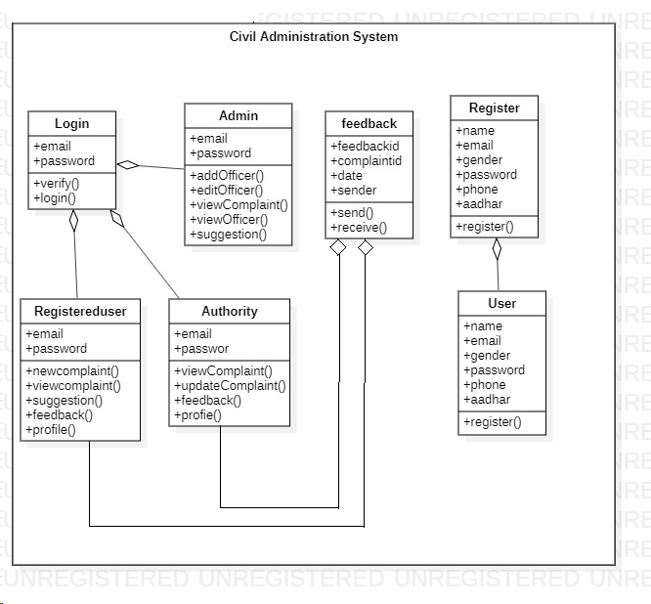

**8.4 UseCase Diagram**

Admin

Authority

**Civil Administrative System**

User

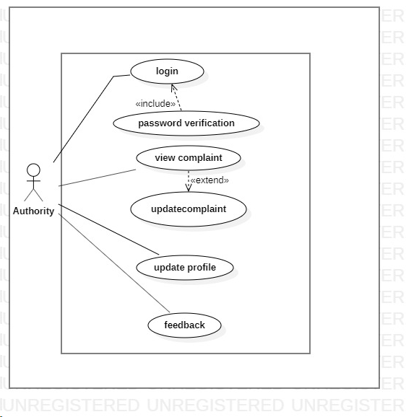



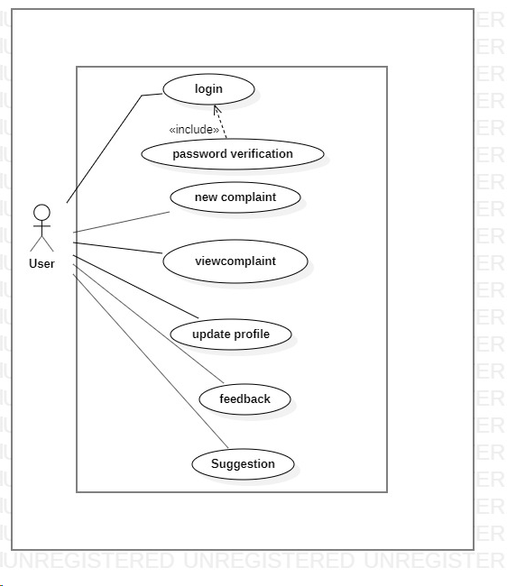

**8.4.1Usecase Description**

1. **Registration**

In order to interact with the system (Civil Administrative Service) a user has to register by providing the required details needed for registration.

**Actors :**Normal User

**Precondition:** The user must have a unique contact number and email address and a Aadhar Number.

**Description:** In order to register user should provide his/her name, email,phone number , Aadhar number ,address ,gender and password which helps in login process and also provide answer to secret Question which helps in recovering the password incase forgot and also accept terms and conditions in order to proceed registration.

**Postcondition:** After Registration, an otp is send to user’s email address for confirming the email and also notifying the he/she is registering.

1. **Login**

The user must login with email id and password in order to access the system.

**Actors:** Normal User, Admin, Authority

**Precondition:**All the actors should have previously registered to the system and they should have a unique email and password.

**Description :** During the login process the actors should input the email and corresponding password and they press login button. The system takes this data and compare it with existing data in the database.If both data match the system takes to the corresponding page according to the actor type. In case the email and password does not match to the corresponding email and password that are stored in the database, a login failure message will be shown and after continuous 5 incorrect attempt will block the user for 1 day to access the system.

**Postcondition:**The system will verify the email and password with the database record, if it fails the system says either no user exists or you have entered wrong password. Otherwise the system provides interface after successfully login.

1. **Complain**

The user complains with their problems either by writings or by uploading picture of problem or by both.

**Actors :**Normal User, Admin, Authority

**Preconditions:** The user must have to login in order to register their complain.

**Description:**When a user faces some problems like health-related problem in locality he/she will try to inform to the **Chief District Medical Officer** and in order to do this the user need to register a complain. For this user must be logged in to the system and go to the new complaints page. In this page a form will appear contains the following fields like title of complain, its subject and complain description and the user also has a option to upload files containing problem information. The user should fill all the fields and submit it .The user will be notified when the complaint is successfully registered.

**Postcondition:**

The system will generate a unique id for every complain. The System save this complain in database and notify to Admin regarding the Complaints.

1. **Complain Status**

This provides the progress of the registered complain.

**Actors :**Normal User, Admin, Authority

**Preconditions:** The Complain should be successfully registered and the complain is assigned to an authority and there should be at least 1 day after assignment of complaint.

**Description :**After a user successfully register the complain and it is assigned by an authority ,the system allows the user to view complain status after 3 days of successfully registration of complain. The Complaint status is updates by authority whenever necessary. The complain status may be unassigned, progress, completed.

**Exception :** If there is no authority for that problem then the status may not be able to maintain.

1. **Feedback**

This provides a way to comment regarding how much they satisfy for the provided solution of their problem

**Actors :**Normal User, Admin.

**Description :** After the solution provided to user’s registered problem , they provides feedback regarding the solution they get and how much they satisfy with the provided solution and also gives suggestion for further improvement of the system. . They can rate to the solution. All the feedback goes to the admin and the admin review the feedback and tries to improve the system.

**8.5 E-R Diagram**

Can Add, Delete,Update

Status

**Authority**

Can

Assign

Authority

**Complain**

**Admin**

**User**

**8.6. Architectural Design**

Large system is generally decomposed to smaller subsystems that account for functionality of the complete software system.

This process of identifying the sub systems and establishing a framework for sub system control and communication is called architectural design.

Architectural design is an important phase, as a bad architectural design cannot be rescued by good implementation. Following activities were performed during this stage:

* Principle sub systems that are functionally independent were identified and distinguished.
* A general model of control relationships between system parts was established.

Each subsystem was further decomposed into their sub function.

Assign Complaint

Gives Complaints

**Administration**

Gives status

Gives response

**Authority**

**User**

Uses

Uses

**Database**

Register details

**Fig. Architecture of Civil Administration**

**Chapter 9. Coding/Code Templates**

**HOME PAGE**

<?php

require 'CSS/index_content.php';

?>

<body >

<div class=" text-center" id="headings" style="width: 100%;height: 150px;background: #0000FF;padding-top: 20px;padding-bottom: 20px ;color: white">

<h1 style= "font-family: verdana; ">Civil Administative Service</h1>

<p >A way to provide services to general public in more refined way</p>

</div>

<!-- Navigation Items -->

<div class="container text-center " style="padding-top: 10px;" >

<div class="btn-group " >

<form action="index.php"><button type="button " class="btnbtn-primary btn-lg active padding">Home</button></form>

<form action="aboutUs.php"><button type="submit" class="btnbtn-primary btn-lg padding" id="aboutus">About Us</button></form>

<form action="adminLogin.php"><button type="submit" class="btnbtn-primary btn-lg padding" onclick="">Admin</button></form>

<form action="authorityLogin.php"><button type="submit" class="btnbtn-primary btn-lg padding">Authority</button></form>

<div class="btn-group">

<button type="button" class="btnbtn-primary dropdown-toggle btn-lg padding" data-toggle="dropdown">

User <span class="caret"></span></button>

<ul class="dropdown-menu" role="menu" style="width: 25%;padding:5px;margin-left: -68px; ">

<li><form action="userRegister.php"><button style="font-size: 16px;width: 100%;padding: 3px;margin-bottom: 2px;">Register</button></form></li>

<li><form action="userLogin.php"><button style="font-size: 16px;width: 100%;padding: 3px">Login</button></form></li>

</ul>

</div>

<form action="contactus.php"><button type="submit" class="btnbtn-primary btn-lg padding" id="contactus">Contact Us</button></form>

</div>

</div>

<div id="mobile_page_design" style="visibility: hidden;">

This is a mobile website

</div>

<div id="description" >

<h2 class="scope"></h2>

<p class="description">

<h3 style="color: red; font-family: verdana; text-align: center; ">Welcome to Civil Administrative System</h3>

<p align="center" style="margin-left:10%;margin-right: 10%;font-size: 18px;background: rgba(255,255,255,0.3);padding: 15px">Civil administration is the administration where the people must abide by the rules that are formed by the government or higher authorities. The complaints given by the public are not reaching the higher authorities on time. In turn it is the public who have to suffer from all these problems. The problems might be related to the roads, education and so on. It will be not possible for the common public to communicate directly with the higher authorities. So to make this task easier, Civil administration system can be developed. It will make the civil administration to work in a smarter way.The system is built to connect the local public with the higher officials in the Civil Administration Office.It enables the common public to lodge their complaints through this system which will notify the higher authorities to take actions regarding problems.</p>

</div>

</body>

</html>

**ADMIN LOGIN**

<?php

require 'Admin/admin_Login.php';

?>

<!DOCTYPE html>

<html lang="en">

<head>

<title>Admin Login</title>

<meta charset="UTF-8">

<meta name="viewport" content="width=device-width, initial-scale=1">

<!--===============================================================================================-->

<link rel="icon" type="image/png" href="images/icons/favicon.ico"/>

<!--===============================================================================================-->

<link rel="stylesheet" type="text/css" href="vendor/bootstrap/css/bootstrap.min.css">

<!--===============================================================================================-->

<link rel="stylesheet" type="text/css" href="fonts/font-awesome-4.7.0/css/font-awesome.min.css">

<!--===============================================================================================-->

<link rel="stylesheet" type="text/css" href="fonts/iconic/css/material-design-iconic-font.min.css">

<!--===============================================================================================-->

<link rel="stylesheet" type="text/css" href="vendor/animate/animate.css">

<!--===============================================================================================-->

<link rel="stylesheet" type="text/css" href="vendor/css-hamburgers/hamburgers.min.css">

<!--===============================================================================================-->

<link rel="stylesheet" type="text/css" href="vendor/animsition/css/animsition.min.css">

<!--===============================================================================================-->

<link rel="stylesheet" type="text/css" href="vendor/select2/select2.min.css">

<!--===============================================================================================-->

<link rel="stylesheet" type="text/css" href="vendor/daterangepicker/daterangepicker.css">

<!--===============================================================================================-->

<link rel="stylesheet" type="text/css" href="css/util.css">

<link rel="stylesheet" type="text/css" href="css/main.css">

<!--===============================================================================================-->

</head>

<body>

<div class="limiter">

<div class="container-login100" style="background-image: url('images/bg-01.jpg');">

<div class="wrap-login100 p-l-55 p-r-55 p-t-65 p-b-54">

<form class="login100-form validate-form" name="AdminLogin" action="adminLogin.php" method="post">

<span class="login100-form-title p-b-49">Login</span>

<div class="wrap-input100 validate-input m-b-23" data-validate = "Username is reauired">

<span class="label-input100">Username</span>

<input class="input100" type="email" name="email" id="email" placeholder="Type Username">

<span class="focus-input100" data-symbol="&#xf206;"></span>

</div>

<div class="wrap-input100 validate-input" data-validate="Password is required">

<span class="label-input100">Password</span>

<input class="input100" type="password" name="password" id="password" placeholder="Type your password">

<span class="focus-input100" data-symbol="&#xf190;"></span>

</div>

<div class="text-right p-t-8 p-b-31">

<a href="forgotPasswordAdmin.php">Forgot password?</a>

</div>

<div class="container-login100-form-btn">

<div class="wrap-login100-form-btn">

<div class="login100-form-bgbtn"></div>

<button class="login100-form-btn" type="submit" value="Login" name="Login"> Login</button>

</div>

</div>

</body>

</html>

**Chapter 10: Testing**

|  |  |  |  |  |  |  |
| --- | --- | --- | --- | --- | --- | --- |
| **Test Case ID** | **Description** | **Step Name** | **Step Description** | **Expected Result** | **Actual Result** | **Remarks** |
| TC_001 | Verify that Password field does not allow only letters. | Step 1 | Launch the application of "Civil Administration System" | Home page should get displayed |  |  |
|  |  | Step 2 | Navigate to New User Registration UI | User Registration UI should get displayed |  |  |
|  |  | Step 3 | Enter valid values in all the mandatory fields and enter values in Password, Confirm Password fields as only lowercase or uppercase letters or combination of both and greater than or equals to 8 characters and click on Submit button | Validation error should get displayed as "Password is invalid. Should contain at least 1 uppercase letter, one lower case letter, 1 number and one special symbol and greater than or equals to 8 characters" | Validation error gets displayed as expected | Pass |
| TC_002 | Verify that Password field does not allow only numbers. | Step 1 | Launch the application of "Civil Administration System" | Home page should get displayed |  |  |
|  |  | Step 2 | Navigate to New User Registration UI | User Registration UI should get displayed |  |  |
|  |  | Step 3 | Enter valid values in all the mandatory fields and enter values in Password, Confirm Password fields as only numbers[0-9] with greater than or equals to 8 characters and click on Submit button | Validation error should get displayed as "Password is invalid. Should contain at least 1 uppercase letter, one lower case letter, 1 number and one special symbol and greater than or equals to 8 characters" | Validation error gets displayed as expected | Pass |
| TC_003 | Verify that Password field does not allow only special Characters. | Step 1 | Launch the application of "Civil Administration System" | Home page should get displayed |  |  |
|  |  | Step 2 | Navigate to New User Registration UI | User Registration UI should get displayed |  |  |
|  |  |  |  |  |  |  |
|  |  | Step 3 | Enter valid values in all the mandatory fields and enter values in Password, Confirm Password fields as only special symbols with greater than or equals to 8 characters and click on Submit button | Validation error should get displayed as "Password is invalid. Should contain at least 1 uppercase letter, one lower case letter, 1 number and one special symbol and greater than or equals to 8 characters" | Validation error gets displayed as expected | Pass |
| TC_004 | Verify that Password field does not allow only letters and numbers | Step 1 | Launch the application of "Civil Administration System" | Home page should get displayed |  |  |
|  |  | Step 2 | Navigate to New User Registration UI | User Registration UI should get displayed |  |  |
|  |  | Step 3 | Enter valid values in all the mandatory fields and enter values in Password, Confirm Password fields as only lowercase or uppercase letters or combination of both along with numbers[0-9] with greater than or equals to 8 characters and click on Submit button | Validation error should get displayed as "Password is invalid. Should contain at least 1 uppercase letter, one lower case letter, 1 number and one special symbol and greater than or equals to 8 characters" | Validation error gets displayed as expected | Pass |
| TC_005 | Verify that Password field does not allow only letters and numbers | Step 1 | Launch the application of "Civil Administration System" | Home page should get displayed |  |  |
|  |  | Step 2 | Navigate to New User Registration UI | User Registration UI should get displayed |  |  |
|  |  |  |  |  |  |  |
|  |  |  |  |  |  |  |
|  |  |  |  |  |  |  |
|  |  | Step 3 | Enter valid values in all the mandatory fields and enter values in Password, Confirm Password fields as only lowercase or uppercase letters or combination of both along with numbers[0-9] with greater than or equals to 8 characters and click on Submit button | Validation error should get displayed as "Password is invalid. Should contain at least 1 uppercase letter, one lower case letter, 1 number and one special symbol and greater than or equals to 8 characters" | Validation error gets displayed as expected | Pass |
| TC_006 | Verify that Password field does not allow only letters and special symbols | Step 1 | Launch the application of "Civil Administration System" | Home page should get displayed |  |  |
|  |  | Step 2 | Navigate to New User Registration UI | User Registration UI should get displayed |  |  |
|  |  | Step 3 | Enter valid values in all the mandatory fields and enter values in Password, Confirm Password fields as only lowercase or uppercase letters or combination of both along with special symbols with greater than or equals to 8 characters and click on Submit button | Validation error should get displayed as "Password is invalid. Should contain at least 1 uppercase letter, one lower case letter, 1 number and one special symbol and greater than or equals to 8 characters" | Validation error gets displayed as expected | Pass |
| TC_007 | Verify that Password field does not allow only numbers and special symbols | Step 1 | Launch the application of "Civil Administration System" | Home page should get displayed |  |  |
|  |  |  |  |  |  |  |
|  |  | Step 2 | Navigate to New User Registration UI | User Registration UI should get displayed |  |  |
|  |  |  |  |  |  |  |
|  |  | Step 3 | Enter valid values in all the mandatory fields and enter values in Password, Confirm Password fields as numbers[0-9] along with special symbols with greater than or equals to 8 characters and click on Submit button | Validation error should get displayed as "Password is invalid. Should contain at least 1 uppercase letter, one lower case letter, 1 number and one special symbol and greater than or equals to 8 characters" | Validation error gets displayed as expected | Pass |
| TC_008 | Verify that Password field does not allow only numbers and special symbols | Step 1 | Launch the application of "Civil Administration System" | Home page should get displayed |  |  |
|  |  | Step 2 | Navigate to New User Registration UI | User Registration UI should get displayed |  |  |
|  |  | Step 3 | Enter valid values in all the mandatory fields and enter values in Password, Confirm Password fields as numbers[0-9] along with special symbols with greater than or equals to 8 characters and click on Submit button | Validation error should get displayed as "Password is invalid. Should contain at least 1 uppercase letter, one lower case letter, 1 number and one special symbol and greater than or equals to 8 characters" | Validation error gets displayed as expected | Pass |
| TC_009 | Verify that Password field allows combination of letters(Uppercase + lowercase), numbers and special symbols | Step 1 | Launch the application of "Civil Administration System" | Home page should get displayed |  |  |
|  |  | Step 2 | Navigate to New User Registration UI | User Registration UI should get displayed |  |  |
|  |  |  |  |  |  |  |
|  |  | Step 3 | Enter valid values in all the mandatory fields and enter values in Password, Confirm Password fields as combination of: 1. Uppercase letters 2. Lowercase letters 3. Numbers[0-9] 4. Special Symbols  with greater than or equals to 8 characters and click on Submit button | New user should get registered successfully and should get displayed with an unique candidate ID | Password is accepted and user registration is successful | Pass |
| TC_010 | Verify that Password field does not allow combination of lowercase letters, numbers and special symbols | Step 1 | Launch the application of "Civil Administration System" | Home page should get displayed |  |  |
|  |  | Step 2 | Navigate to New User Registration UI | User Registration UI should get displayed |  |  |
|  |  | Step 3 | Enter valid values in all the mandatory fields and enter values in Password, Confirm Password fields as a combination of lowercase alphabets, numbers[0-9] along with special symbols with greater than or equals to 8 characters and click on Submit button | Validation error should get displayed as "Password is invalid. Should contain at least 1 uppercase letter, one lower case letter, 1 number and one special symbol and greater than or equals to 8 characters" | Validation error gets displayed as expected | Pass |
| TC_011 | Verify that Password field does not allow combination of uppercase letters, numbers and special symbols | Step 1 | Launch the application of "Civil Administration System" | Home page should get displayed |  |  |
|  |  | Step 2 | Navigate to New User Registration UI | User Registration UI should get displayed |  |  |
|  |  | Step 3 | Enter valid values in all the mandatory fields and enter values in Password, Confirm Password fields as a combination of uppercase alphabets, numbers[0-9] along with special symbols with greater than or equals to 8 characters and click on Submit button | Validation error should get displayed as "Password is invalid. Should contain at least 1 uppercase letter, one lower case letter, 1 number and one special symbol and greater than or equals to 8 characters" | Validation error gets displayed as expected | Pass |
| TC_012 | Verify that Password field does not allow any combination of letters(uppercase and lowercase), numbers[0-9] and special characters if the password length is less than 8 characters. | Step 1 | Launch the application of "Civil Administration System" | Home page should get displayed |  |  |
|  |  | Step 2 | Navigate to New User Registration UI | User Registration UI should get displayed |  |  |
|  |  | Step 3 | Enter valid values in all the mandatory fields and enter values in Password, Confirm Password fields as any combination of uppercase, lowercase alphabets, numbers[0-9] and special symbols with less than 8 characters in length and click on Submit button | Validation error should get displayed as "Password is invalid. Should contain at least 1 uppercase letter, one lower case letter, 1 number and one special symbol and greater than or equals to 8 characters" | Validation error gets displayed as expected | Pass |
| TC_013 | Verify that appropriate validation error gets displayed when the values in Password and Confirm Password fields don't match | Step 1 | Launch the application of "Civil Administration System" | Home page should get displayed |  |  |
|  |  | Step 2 | Navigate to New User Registration UI | User Registration UI should get displayed |  |  |
|  |  | Step 3 | Enter valid values in all the mandatory fields and enter different values in Password, Confirm Password fields as any combination of uppercase, lowercase alphabets, numbers[0-9] and special symbols with greater than or equal to 8 characters length and click on Submit button | Validation error should get displayed as "Values of Password and Confirm Password must match" | Validation error gets displayed as expected | Pass |

**Chapter 11: Database Design View**

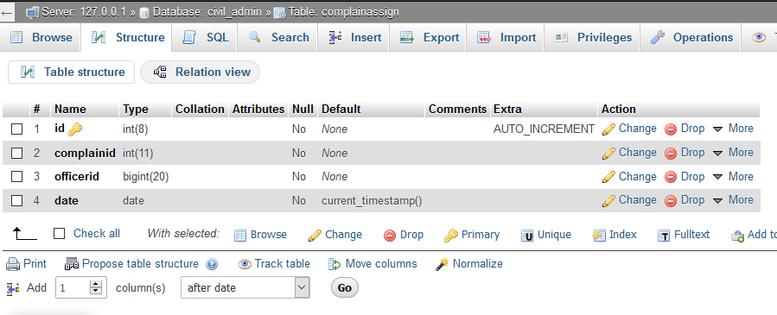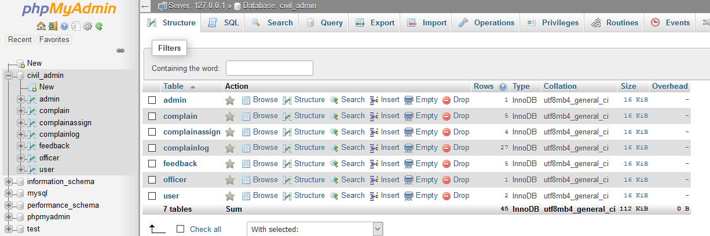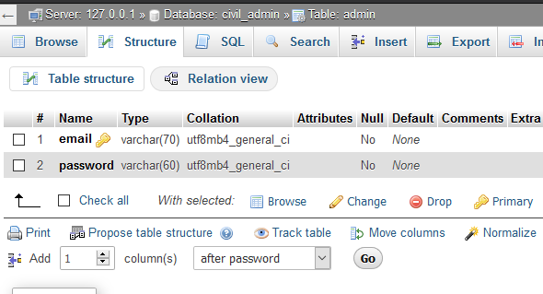

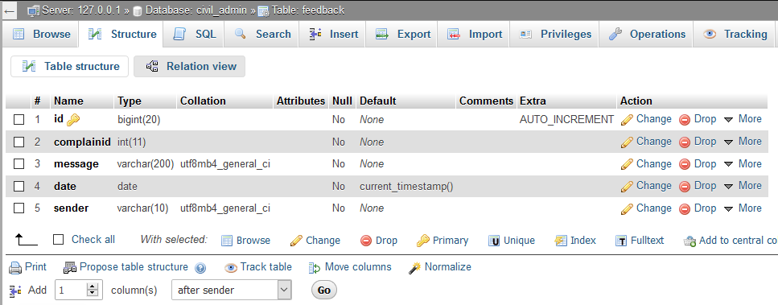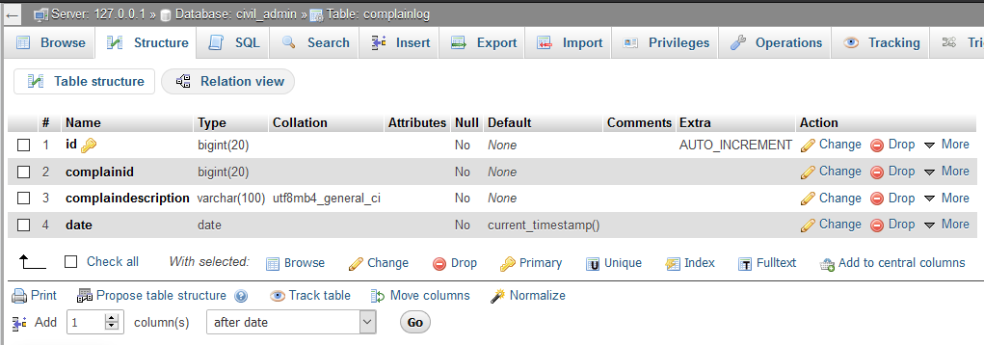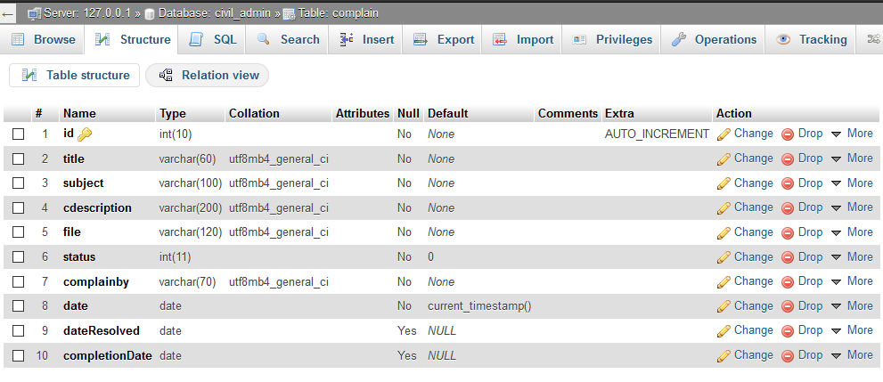

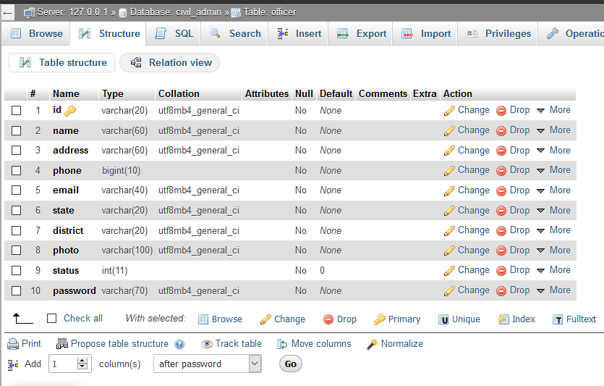

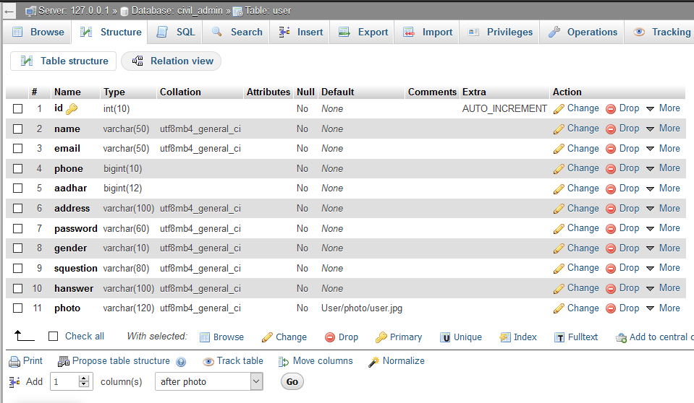

**Chapter 12: Output Screens**

**Website**

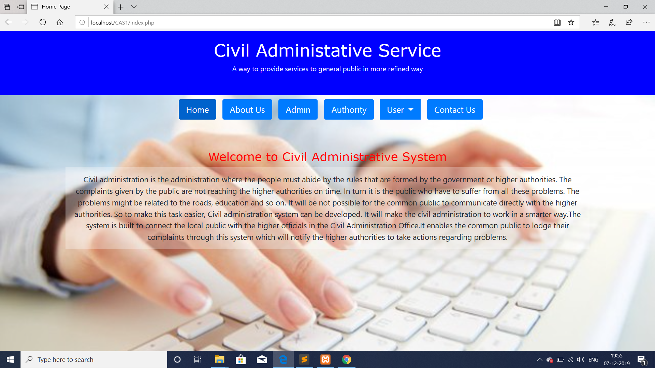

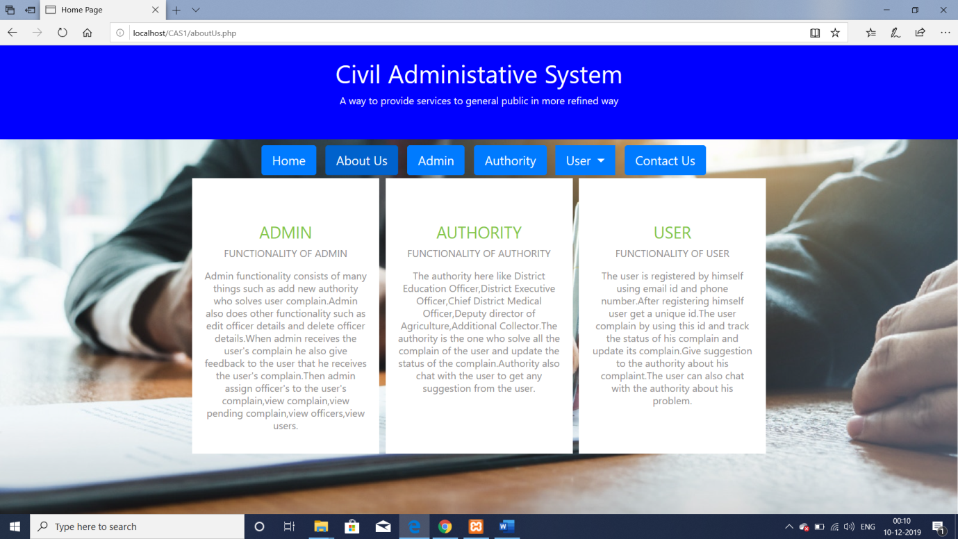

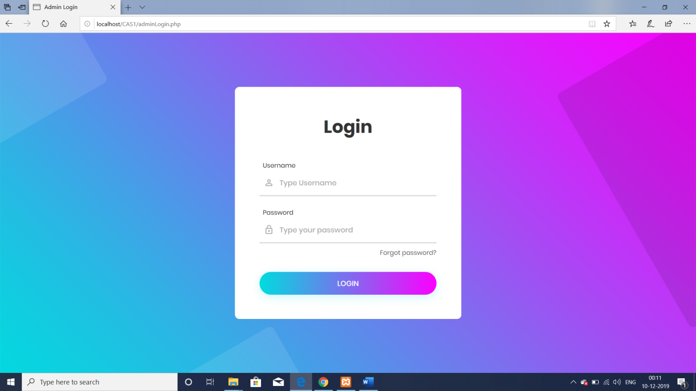

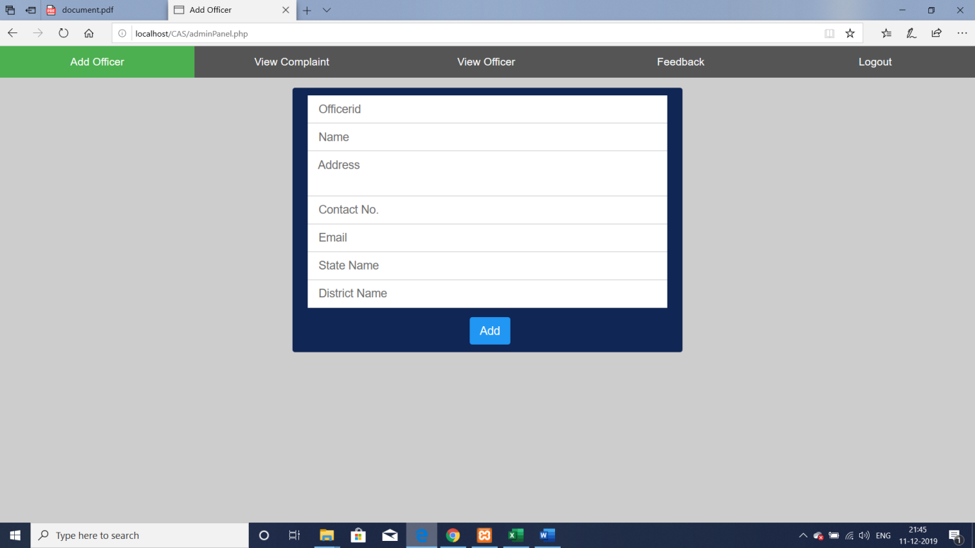

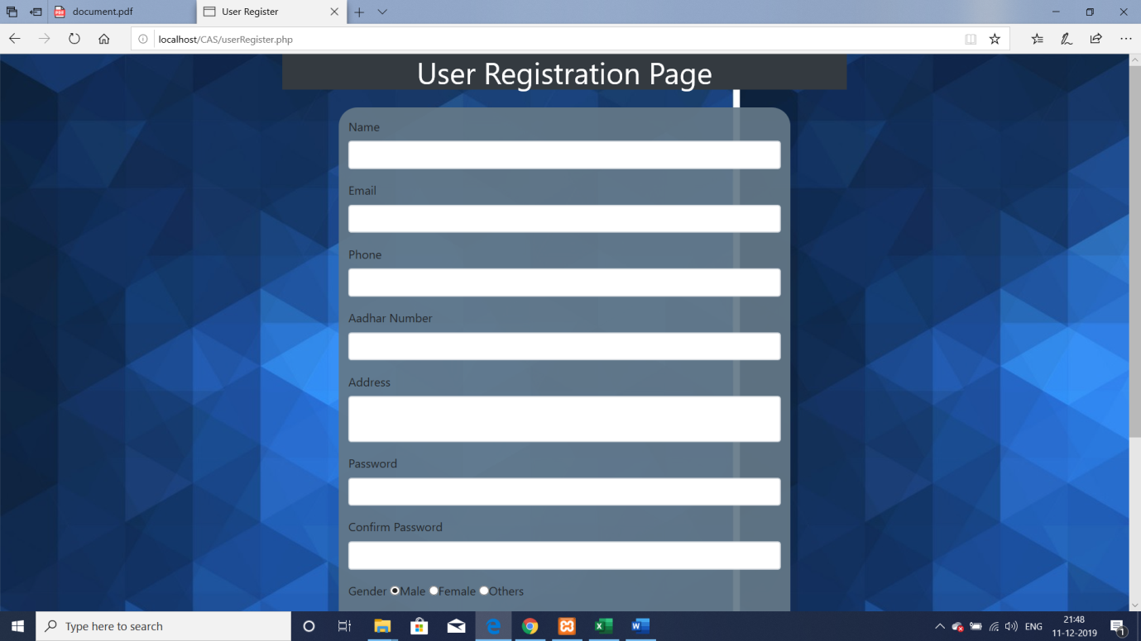

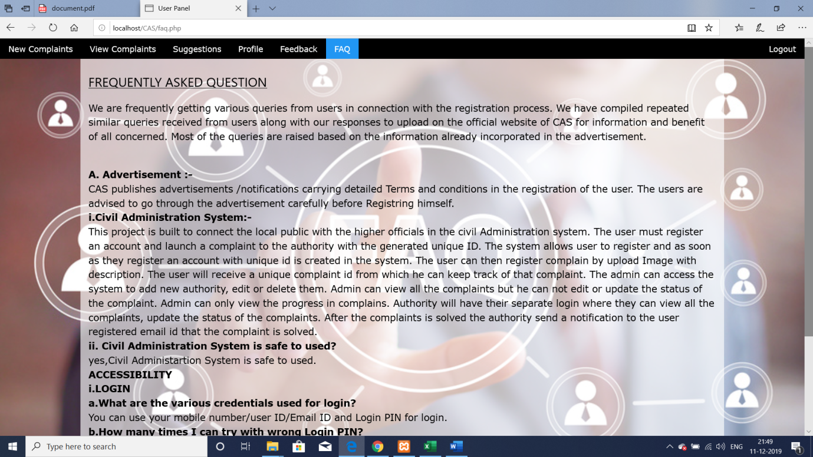

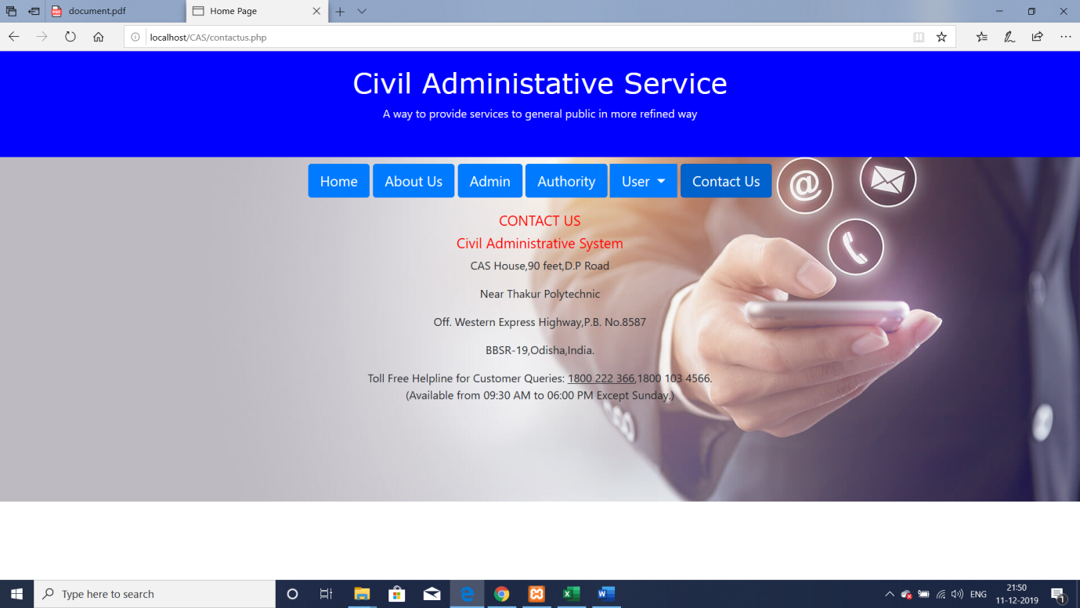

**Mobile APP**

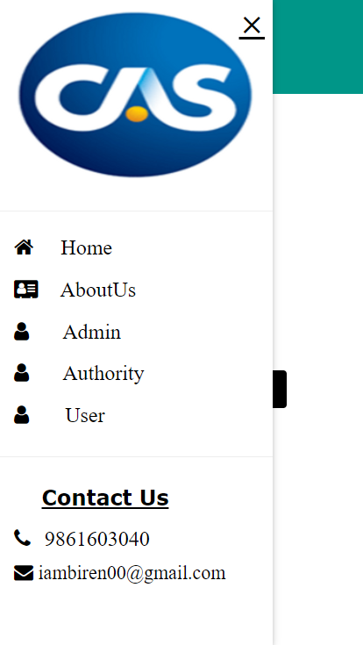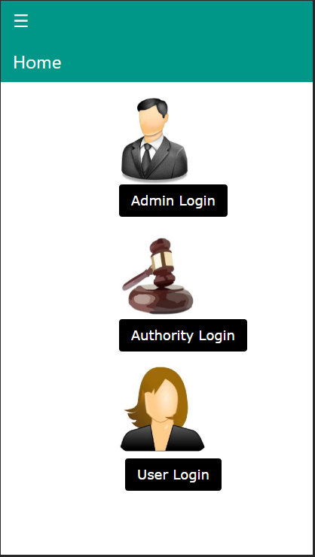

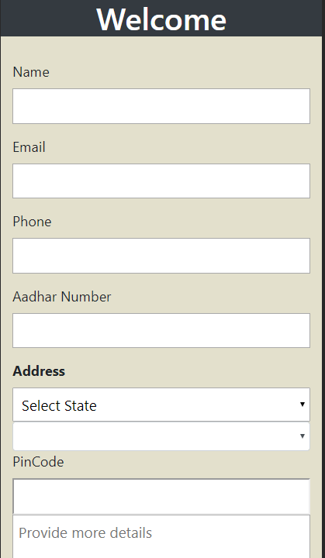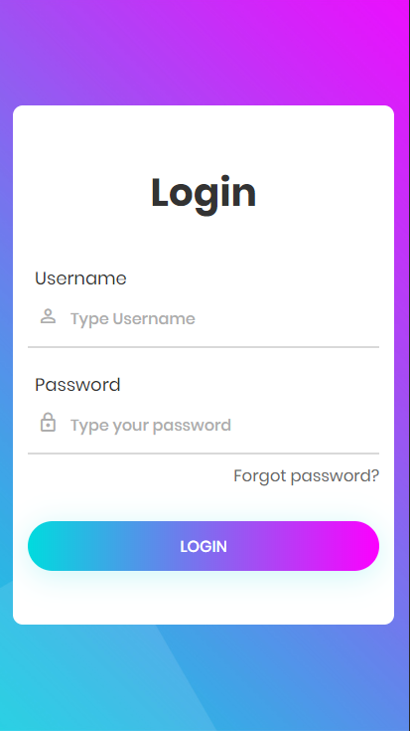

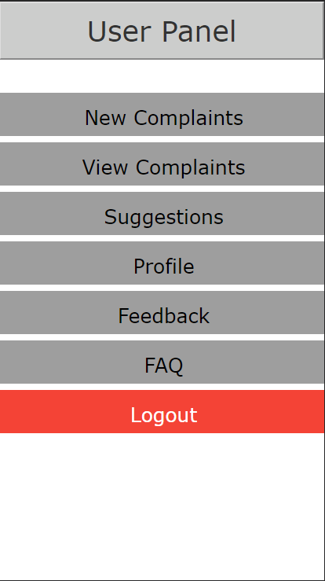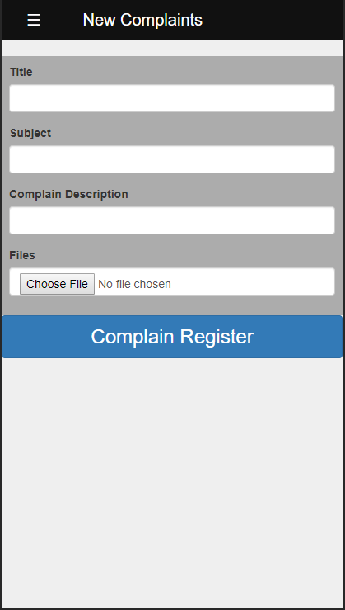

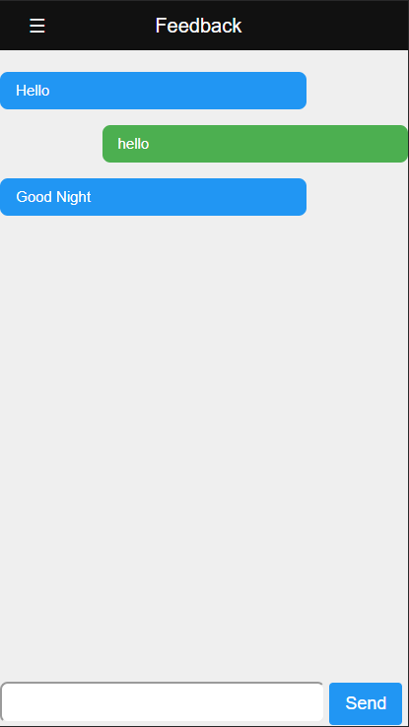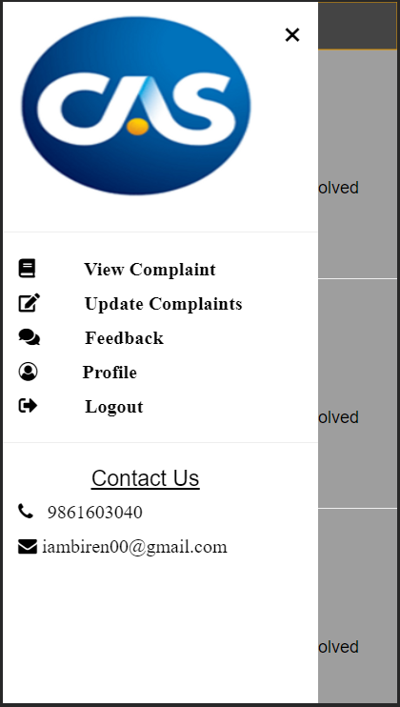

**Chapter 13: Conclusion**

**13.1 LIMITATIONSAND SCOPE FOR FUTURE ENHANCEMENTS:**

**13.1.1 Limitations of the System:**

* + System only works in specific platforms and its compatible environments.
  + Advanced techniques are not used to check the authorization.

**13.1.2 Future Enhancements:**

It is not possible to develop a system that makes all the requirements of the user. User requirements keep changing as the system is being used. Some of the future enhancements that can be done to this system are:

* As the technology emerges, it is possible to upgrade the system and can be adaptable to desired environment.
* Because it is based on object-oriented design, any further changes can be easily adaptable.
* Based on the future security issues, security can be improved using emerging technologies.
* Sub admin module can be added
* GPS tracking can be implemented in order to track particular location from where the user registers the complain.

**13.1.3 PROJECT SUMMARY**

This application software has been computed successfully and was also tested successfully by taking “test cases”. It is user friendly, and has required options, which can be utilized by the user to perform the desired operations.

The software is developed using php as front end and mysql as back end in Windows environment . The goals that are achieved by the software are:

* Optimum utilization of resources.
* Efficient management of records.
* Simplification of the operations.
* Less processing time and getting required information.
* User friendly.
* Portable and flexible for further enhancement.

**13.2 Work Done**

**The Civil Administrative System** was successfully designed and is tested for accuracy and quality.

During this project we have accomplished all the objectives and this project meets the needs of the organization. The developed project will be used in searching, retrieving and generating information for the concerned requests.

**GOALS**

* + Reduced time needed previously for paper work
  + Easy retrieval of information
  + User friendly screens to enter the data
  + Portable and flexible for further enhancement
  + Web enabled.
  + Fast finding of information requested

**Chapter 14: References/Bibliography**

<https://www.w3schools.com/>

<https://developers.google.com/android/>

<https://www.android.com/>

<https://developer.android.com/studio/index.html>

<https://in.udacity.com/courses/android>

<https://in.udacity.com/courses/web>